**FAISAL RASOOL QAZI**

**ROLL NO: 455689**

**ME-15 Sec-B**

**//TASK 01**

#include <iostream>

#include <vector>

using namespace std;

int main()

{

vector<int> myVector;

for (int i = 1; i <= 10; ++i)

myVector.push_back(i);

cout << "Elements in the vector: ";

for (auto y = myVector.begin(); y != myVector.end(); ++y)

cout << *y << " ";

cout << endl;

myVector.push_back(5);

cout << "Vector after pushing 5: ";

for (auto y = myVector.begin(); y != myVector.end(); ++y)

cout << *y << " ";

cout << endl;

if (!myVector.empty() && myVector.size() > 2) {

auto itToRemove = myVector.begin() + 1;

myVector.erase(itToRemove);

}

cout << "Vector after removing element at position 2: ";

for (auto y = myVector.begin(); y != myVector.end(); ++y)

cout << *y << " ";

cout <<endl;

return 0;

}

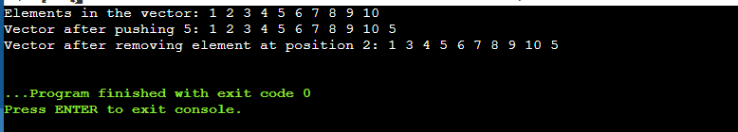

**//TASK 02**

#include <iostream>

#include <vector>

#include <algorithm>

using namespace std;

int main() {

int numPairs;

cout<<"Enter the number of names/grades : ";

cin>>numPairs;

vector<string>names;

vector<int>grades;

for(int i=0; i<numPairs; ++i) {

string name;

int grade;

cout<<"Enter name #"<<i+1<<": ";

cin>>name;

names.push_back(name);

cout<<"Enter grade #"<<i+1<<": ";

cin>>grade;

grades.push_back(grade);

}

// Calculating the mean

double sum =0.0;

for(int grade : grades) {

sum = sum + grade;

}

double mean= sum/numPairs;

cout<<"Mean of the grades: "<<mean<<endl;

// Calculating median

sort(grades.begin(), grades.end());

double median;

if(numPairs % 2==0){

median=(grades[numPairs/2-1] + grades[numPairs/2]) /2.0;

}else{

median=grades[numPairs/2];

}

cout<<"Median of the grades:"<<median<<endl;

// Calculating mode

vector<int> counts(101, 0);

for(int grade : grades){

counts[grade]++;

}

int mode = distance(counts.begin(), max_element(counts.begin(), counts.end()));

cout<<"Mode of the grades: "<<mode<<endl;

// Display names with mode as their grade

cout << "Students with the mode as their grade:"<<endl;

for(size_t i=0; i<grades.size(); ++i){

if(grades[i] == mode){

cout<<names[i]<<endl;

}

}

return 0;

}

